**NAME** :- Manish Shashikant Jadhav

**UID** :- 2023301005.

**BRANCH** :- Comps -B. **BRANCH:** B.

**EXPERIMENT 5:** Implement ADT for storing a BST and performing operations on it.

**SUBJECT** :- DS (DATA STRUCTURES).

**CODE** :-

#include <stdio.h>

#include <stdlib.h>

// Define the structure for a binary tree node

struct TreeNode {

    int data;

    struct TreeNode* left;

    struct TreeNode* right;

};

// Function to create a new node

struct TreeNode* createNode(int data) {

    struct TreeNode* newNode = (struct TreeNode*)malloc(sizeof(struct TreeNode));

    newNode->data = data;

    newNode->left = NULL;

    newNode->right = NULL;

    return newNode;

}

// Function to insert a node into the binary tree

struct TreeNode* insertNode(struct TreeNode* root, int data) {

    if (root == NULL) {

        return createNode(data);

    }

    if (data < root->data) {

        root->left = insertNode(root->left, data);

    } else if (data > root->data) {

        root->right = insertNode(root->right, data);

    }

    return root;

}

// Function to find the minimum value node in the binary tree

struct TreeNode* findMinValueNode(struct TreeNode* root) {

    if (root == NULL || root->left == NULL) {

        return root;

    }

    return findMinValueNode(root->left);

}

// Function to find the maximum value node in the binary tree

struct TreeNode* findMaxValueNode(struct TreeNode* root) {

    if (root == NULL || root->right == NULL) {

        return root;

    }

    return findMaxValueNode(root->right);

}

// Function to display the binary tree using inorder traversal

void displayTree(struct TreeNode* root) {

    if (root != NULL) {

        displayTree(root->left);

        printf("%d ", root->data);

        displayTree(root->right);

    }

}

// Function to delete a node with a specific value

struct TreeNode* deleteNode(struct TreeNode* root, int data) {

    if (root == NULL) {

        return root;

    }

    if (data < root->data) {

        root->left = deleteNode(root->left, data);

    } else if (data > root->data) {

        root->right = deleteNode(root->right, data);

    } else {

        // Node with only one child or no child

        if (root->left == NULL) {

            struct TreeNode* temp = root->right;

            free(root);

            return temp;

        } else if (root->right == NULL) {

            struct TreeNode* temp = root->left;

            free(root);

            return temp;

        }

        // Node with two children: Get the in-order successor (smallest in the right subtree)

        struct TreeNode* temp = findMinValueNode(root->right);

        // Copy the in-order successor's data to this node

        root->data = temp->data;

        // Delete the in-order successor

        root->right = deleteNode(root->right, temp->data);

    }

    return root;

}

// Function to find a node with a specific value

struct TreeNode* findNode(struct TreeNode* root, int data) {

    if (root == NULL || root->data == data) {

        return root;

    }

    if (data < root->data) {

        return findNode(root->left, data);

    } else {

        return findNode(root->right, data);

    }

}

// Function to swap values of two nodes with specific values

void swapNodeValues(struct TreeNode* root, int value1, int value2) {

    struct TreeNode* node1 = findNode(root, value1);

    struct TreeNode* node2 = findNode(root, value2);

    if (node1 == NULL || node2 == NULL) {

        printf("One or both values not found in the tree.\n");

        return;

    }

    int temp = node1->data;

    node1->data = node2->data;

    node2->data = temp;

}

int main() {

    struct TreeNode* root = NULL;

    root = insertNode(root, 28);

    root = insertNode(root, 9);

    root = insertNode(root, 13);

    root = insertNode(root, 2);

    root = insertNode(root, 11);

    root = insertNode(root, 7);

    root = insertNode(root, 18);

    root = insertNode(root, 10);

    printf("Binary Tree Inorder Traversal: ");

    displayTree(root);

    printf("\n");

    struct TreeNode* minNode = findMinValueNode(root);

    printf("Minimum Value Node: %d\n", minNode->data);

    struct TreeNode* maxNode = findMaxValueNode(root);

    printf("Maximum Value Node: %d\n", maxNode->data);

    int valueToFind = 18;

    struct TreeNode* nodeToFind = findNode(root, valueToFind);

    if (nodeToFind != NULL) {

        printf("Node with value %d found in the tree.\n", valueToFind);

    } else {

        printf("Node with value %d not found in the tree.\n", valueToFind);

    }

    int valueToDelete = 7;

    root = deleteNode(root, valueToDelete);

    printf("Binary Tree after deleting node with value %d: ", valueToDelete);

    displayTree(root);

    printf("\n");

    int valueToSwap1 = 28;

    int valueToSwap2 = 13;

    swapNodeValues(root, valueToSwap1, valueToSwap2);

    printf("Binary Tree after swapping values %d and %d: ", valueToSwap1, valueToSwap2);

    displayTree(root);

    printf("\n");

    // Clean up memory (optional)

    free(root);

    return 0;

}

**Output:**

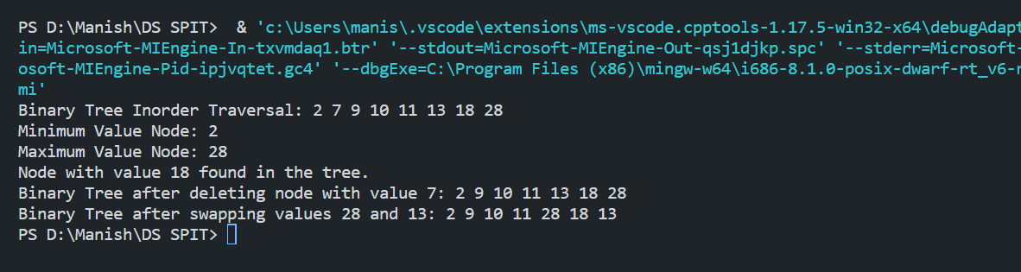

**Algorithm:**

**1. Define the structure for a binary tree node (struct TreeNode).**

**2. Implement a function to create a new node:**

- createNode(int data) -> struct TreeNode*

- Allocate memory for a new node.

- Initialize the data, left, and right pointers.

- Return the new node.

**3. Implement a function to insert a node into the binary tree:**

- insertNode(struct TreeNode* root, int data) -> struct TreeNode*

- If the root is NULL, create a new node with the given data and return it.

- If data is less than the root's data, recursively insert into the left subtree.

- If data is greater than the root's data, recursively insert into the right subtree.

- Return the updated root.

**4. Implement a function to find the minimum value node in the binary tree:**

- findMinValueNode(struct TreeNode* root) -> struct TreeNode*

- Recursively navigate to the left child until you reach a leaf node.

- Return the leaf node (minimum value node).

**5. Implement a function to find the maximum value node in the binary tree:**

- findMaxValueNode(struct TreeNode* root) -> struct TreeNode*

- Recursively navigate to the right child until you reach a leaf node.

- Return the leaf node (maximum value node).

**6. Implement a function to display the binary tree using inorder traversal:**

- displayTree(struct TreeNode* root) -> void

- If the root is not NULL:

- Recursively call displayTree on the left subtree.

- Print the data of the current node.

- Recursively call displayTree on the right subtree.

**7. Implement a function to delete a node with a specific value from the binary tree:**

- deleteNode(struct TreeNode* root, int data) -> struct TreeNode*

- If the root is NULL, return it.

- If data is less than the root's data, recursively delete from the left subtree.

- If data is greater than the root's data, recursively delete from the right subtree.

- If the data matches the root's data:

- Handle cases where the node has one or no children.

- For nodes with two children, replace the data with the minimum value from the right subtree and delete that node.

- Return the updated root.

**8. Implement a function to find a node with a specific value:**

- findNode(struct TreeNode* root, int data) -> struct TreeNode*

- If the root is NULL or its data matches the search data, return it.

- If data is less than the root's data, recursively search in the left subtree.

- If data is greater than the root's data, recursively search in the right subtree.

**9. Implement a function to swap values of two nodes with specific values:**

- swapNodeValues(struct TreeNode* root, int value1, int value2) -> void

- Find the nodes with value1 and value2 in the tree.

- If either of the nodes is not found, display an error message.

- Swap the values of the two nodes.

**10. In the main function:**

- Create an empty binary tree (root is NULL).

- Insert several nodes with values.

- Display the tree using inorder traversal.

- Find and print the minimum and maximum value nodes.

- Find and print whether a specific node with a value exists in the tree.

- Delete a node with a specific value and display the tree.

- Swap the values of two nodes and display the tree.

- Optionally, clean up memory by freeing allocated nodes.

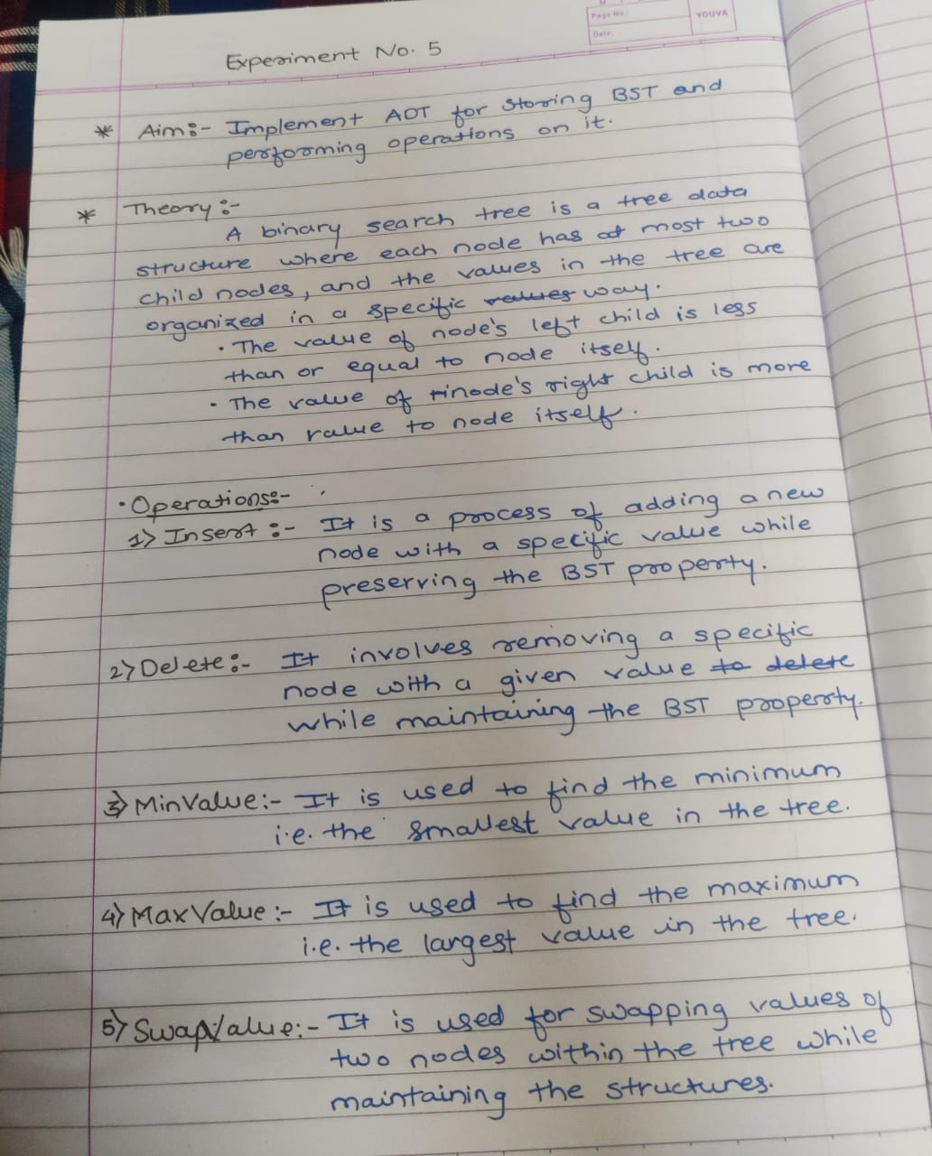

**Conclusion:**

Hence, by completing this experiment I came to know about implement ADT for storing a BST and performing operations on it.